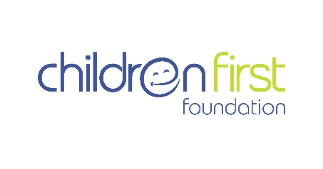
Child’s Referral Form

CHILD’S DETAILS

Child’s first name _____________________________________________________________

Child’s family name or surname __________________________________________________

Date of birth: _________________________________Male ________ Female ___________

Child’s home address (include region/district/country: _______________________________

_____________________________________________________________________________

____________________________________________________________________________

FAMILY DETAILS:

Child’s father’s name _________________________________________________________

Child’s mother’s name: ________________________________________________________

Who is the child’s primary care giver? Mother ____ and/or Father ____ Other ______

If ‘other’ provide the name of the care giver: _______________________________________

Care giver’s relationship to child ___________________________________________________ (ie: grandmother, aunt, friend?)

Phone number of parents’ or care giver: ___________________________________________

What language to you speak at home? _____________________________________________

How many children do you have? _________What age are your other children? ____________

CHILD’S MEDICAL INFORMATION
We require as much medical information as you can provide. This includes a letter of referral from your child’s doctor or surgeon, and any x-rays, blood tests, medical reports that will enable our surgeons to assess your child’s condition for surgery in Australia.

Please describe the child’s medical condition in detail.

________________________________________________________________________

________________________________________________________________________

What treatment has the child received?

_________________________________________________________________________

_________________________________________________________________________

Is the child receiving treatment now? Yes or No. If yes, please give details

_________________________________________________________________________

_________________________________________________________________________

Is the child on any medication? Yes or No. If yes, what medication?

___________________________________________________________________________

Has the child undergone surgery? Yes or No: If yes, please provide details, and dates of surgery ________________________________________________________________________

________________________________________________________________________

Please provide the name and contact details of the child’s treating doctor/s

________________________________________________________________________

Children First Foundation, 66 Chapman Street, North Melbourne 3051 Victoria, Australia
marina@childrenfirstfoundation.org.au Telephone: +61 3 9329 4822

